Parish of Aston Cantlow

A meeting of the Parish Council for the above named Parish will be held on 18th January 2024 in Aston Cantlow Village Hall at 7.00pm

Dated this 11th day of January 2024
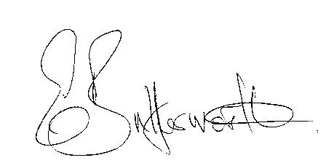Clerk

BUSINESS TO BE TRANSACTED

- Record of Members present.

- To receive apologies and approve reasons for absence.
- Declarations of interest in items on the agenda.
- Sarah Brooke-Taylor, WRCC Rural Housing Enabler regarding an area of land off Bearley Road to the North of the village. The Landowner is, in principle, happy for the site to be considered for the development of local needs housing.
- To approve the minutes of the Parish Council meeting held on the 9th November 2023.
- Public participation.
- Correspondence: All correspondence circulated electronically is taken as read
- Mill Lane traffic safety provisions and traffic calming in Little Alne.
- County & District Councillors’ reports.
10. To agree precept request for the 2024/25.

11. Defibrillator update.
12. Planning applications update.
13. Parish Council assets. Report from Cllrs after inspection.
14. Flooding in the Parish.
15. Review/update of Website. This matter is ongoing.
16. Update on matters since the previous meeting.
17. Warwickshire County Council’s Rights of Way Improvement Plan (ROWIP).
18. Urgent items not on the agenda raised by Councillors.
19. To propose other items of business for consideration at the next meeting.
20. Date of next meeting: 14th March 2024. Annual Parish meeting followed by an
ordinary parish council meeting.

