Parish of Aston Cantlow

A meeting of the Parish Council for the above named Parish will be held on 19th January 2023 at 7.00 pm in Aston Cantlow Village Hall

Dated this 14th day of January 2023
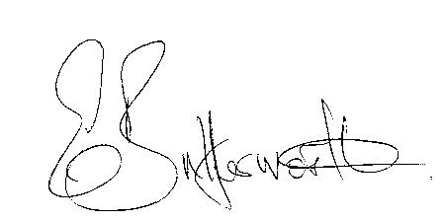Clerk

BUSINESS TO BE TRANSACTED

- Record of Members present.
- To receive apologies and approve reasons for absence.
- Declarations of interest in items on the agenda.
- To approve the minutes of the Parish Council meeting held on 10th November 2022 and extraordinary Parish Council meeting held on 30th November 2022.
- Public participation.
- Community Speedwatch/Traffic Calming.
- County & District Councillors’ reports.
- Planning applications update and to consider the following:
Application No. 22/03628/VARY Ardencote Farm, Shelfield Green. Variation of Condition 2 of planning permission 18/01821/FUL.
Application Nos. 23/0030/FUL and 23/0031/LBC Ardencroft, Newnham: Replacement single storey rear conservatory.
9. Final Precept request to be considered and approved.

10. Bank Mandate for completion.

11. Urgent items not on the agenda raised by Councillors.

12. To propose other items of business for consideration at the next meeting.

14. Date of next meeting: 16th March 2023. Annual Parish Assembly followed by ordinary Parish
Council meeting.

