Parish of Aston Cantlow

A meeting of the Parish Council for the above named Parish will be held on 28th^{th} July 2022 at 7.00 pm in Aston Cantlow Village Hall

Dated this 23rd day of July 2022
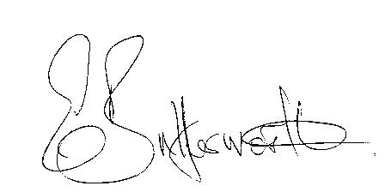Clerk

BUSINESS TO BE TRANSACTED

- Record of Members present.
- To receive apologies and approve reasons for absence.
- Declarations of interest in items on the agenda.
- To approve the minutes of the Annual Parish Assembly, Annual Parish Council meeting and ordinary meeting held on 12th May 2022.
- Public participation.
- Community Speedwatch.
- County & District Councillors’ reports.
- Planning applications: current status.
9. Request from Aston Cantlow Village Hall Committee for a grant towards the maintenance of the playground.
10. To consider applications from interested parties applying to be co-opted onto the council.
11. Date of next meeting: 15th September 2022.

