Parish of Aston Cantlow

A meeting of the Parish Council for the above named Parish will be held on 29th September 2022 at 7.00 pm in Aston Cantlow Village Hall

Dated this 23rd day of September 2022
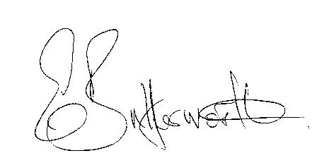Clerk

BUSINESS TO BE TRANSACTED

- Record of Members present.
- To receive apologies and approve reasons for absence.
- Declarations of interest in items on the agenda.
- To approve the minutes of the Annual Parish Assembly, Annual Parish Council meeting and ordinary meeting held on 12th May 2022.
- Public participation.
- Community Speedwatch.
- County & District Councillors’ reports.
- Planning applications: current status.
9. Request from Aston Cantlow Village Hall Committee for a grant towards the maintenance of the playground.
10. To consider co-option of applicants who have expressed an interest in becoming a member of the parish council.
11. Date of next meeting: 10th November 2022

