Parish of Aston Cantlow

A meeting of the Parish Council for the above named Parish will be held on 31st January 2022 at 7.00 pm in Aston Cantlow Village Hall

Dated this 26th day of January 2022
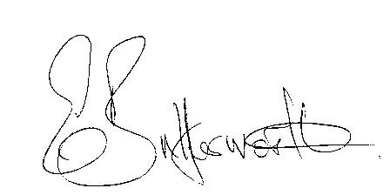Clerk

BUSINESS TO BE TRANSACTED

- Record of Members present.
- To receive apologies and approve reasons for absence.
- Declarations of interest.
- Public participation.
- County & District Councillors’ reports.
- Planning application pending:
Planning application 22/00073/FUL 9 Bearley Road, Aston Cantlow: Single storey rear infill extension to kitchen.
7. Precept 2022/23
8. Date of next meeting: 10th March 22

