Parish of Aston Cantlow

A meeting of the Parish Council for the above named Parish will be held on 9th November 2023 in Aston Cantlow Village Hall at 7.00pm

Dated this 4th day of November 2023
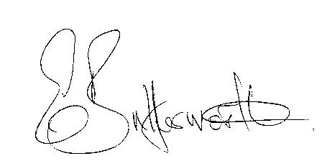Clerk

BUSINESS TO BE TRANSACTED

- Record of Members present.
- To receive apologies and approve reasons for absence.
- Declarations of interest in items on the agenda.
- To approve the minutes of the Parish Council meeting held on 14th September 2023.
- Public participation.
- Correspondence: All correspondence circulated electronically is taken as red.
- Mill Lane traffic safety provisions.
- Community Speedwatch/Traffic Calming Little Alne.
- County & District Councillors’ reports.
- Planning applications update.
11. Defibrillator
12. Aston Cantlow Village Hall request for contribution towards the cost of curtains to match fund a grant from County Cllr. Kerridge.
13. Parish Council Assets.

14. Review/update of Website.

15. Update on matters since the previous meeting.

16. Urgent items not on the agenda raised by Councillors.

17. To propose other items of business for consideration at the next meeting.

18. Date of next meeting: 18th January 2024

