NOTICE OF EXTRAORDINARY MEETING
OF PARISH COUNCIL

Dear Councillor

You are hereby summoned to attend a meeting of Aston Cantlow Parish Council to be held in Aston Cantlow Village Hall on 30th November 2022 at 7.00 p.m. for the purpose of transacting the following business.

BUSINESS TO BE TRANSACTED

- Present

- Apologies for absence

- To receive written requests for Disclosable Pecuniary Interests.

- Cllr. Forman to step down – election of new Chairman

Dated this 25th day of November 2022
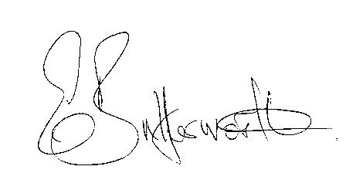Clerk

