Parish of Aston Cantlow

A meeting of the Parish Council for the above named Parish will be held on 14th September 2023 in Aston Cantlow Village Hall
at 7.00 pm

Dated this 9th day of September 2023
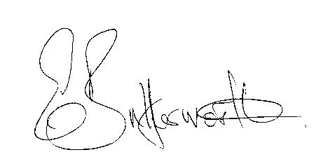Clerk

BUSINESS TO BE TRANSACTED

- Record of Members present.
- To receive apologies and approve reasons for absence.
- Declarations of interest in items on the agenda.
- To approve the minutes of the Parish Council meeting held on 13th July 2023
- Public participation. Request for Defibrillator in Little Alne.
- Mill Lane traffic safety provisions.
- Community Speedwatch/Traffic Calming Little Alne.
- County & District Councillors’ reports.
- Planning applications update.
10. Request for litter bin by new stile adjacent to bridge in Little Alne.
11. Request for horse gate at entrance to bridleway from Bearley Road.

12a. Aston Cantlow Tennis Club request for contribution towards the cost of portable lights to fund a grant from County Cllr. Kerridge.
b. Aston Cantlow Village Hall request for contribution towards the cost of curtains to match fund a grant from County Cllr. Kerridge.

13. Request from owner of Home Farm to have the public bin moved across the road.

14. Review/update of Website.

15. Update on matters since the previous meeting.

16. Urgent items not on the agenda raised by Councillors.

17. To propose other items of business for consideration at the next meeting.

18. Date of next meeting: 9th November 2023

