Parish of Aston Cantlow

A meeting of the Parish Council for the above named Parish will be held on 10th April 2024 in Aston Cantlow Village Hall following the Annual Parish Assembly.

Dated this 5th day of April 2024
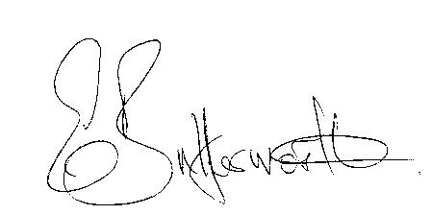Clerk

BUSINESS TO BE TRANSACTED

- Election of Chair
- To receive apologies and approve reasons for absence.
- Declarations of interest in items on the agenda.
- To approve the minutes of the Parish Council meeting held on the 18th January 2024.
- To consider requests from Mr. R. Mason and Mr P. Walters to be co-opted onto the Council. There are currently two vacant seats.
- Public participation.
- Correspondence: All correspondence circulated electronically is taken as read
- County & District Councillors’ reports.
9. Planning applications update.
10. Litter bin by Lych Gate.
11. D.Day 80th Anniversary.
12. Communication routes to residents.
13. Update on matters since the previous meeting:
Flooding: A member of the County Council Flood Risk Team has been invited to attend
the July meeting and Emergency plan templates have been obtained for consideration.
Defibrillator for Little Alne: the equipment has now been received and is in full working order. A training seminar is due to take place on the 9th May in the village hall.

WRCC Housing Needs Scheme: Discussions have taken place between the Rural Housing Enabler & a landowner who has decided not to proceed.

14. Urgent items not on the agenda raised by Councillors.
15. To propose other items of business for consideration at the next meeting.
16. Date of next meeting: 9th May 2024. Annual Parish Council meeting followed by an
ordinary parish council meeting.

