Parish of Aston Cantlow

NOTICE OF ORDINARY

PARISH COUNCIL MEETING FOLLOWING THE ANNUAL MEETING

Dated this 15th day of January 2021
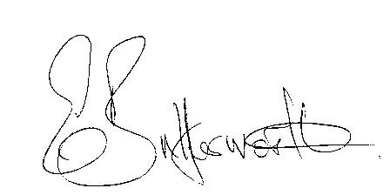Clerk

BUSINESS TO BE TRANSACTED

- Record of Members present.
- To receive apologies and approve reasons for absence.
- To receive written requests for Disclosable Pecuniary Interests or Non-Pecuniary interests where that interest is not already in the register of members’ interests.
- To approve the minutes of the Parish Council meeting held on 12th November 2020.
- Public participation: To receive any questions or presentations from the public.
- County & District Councillors reports.
- Planning Matters. Amendment application 20/02871/FUL 2 Wheathills Cottage
20/0961/FUL Millbank recommended for conditional approval. Does PC wish to re-visit the application.
- Correspondence received: All correspondence sent electronically to date will be taken as read.
- Final agreed Precept request for 2021/22.
- Consultation: Draft Gypsy and Traveller and Travelling Showpeople Supplementary Planning Document (SPD).
- Asset inspection 2020.
- Parking on the village green.
- B4089 traffic speeds through Little Alne.
- Plans for expenditure in 2021/22 particularly in relation to flooding.
- Review of Lengthsman scheme.
16. Date of next meeting: 11th March 2021.

